***Discussion—***

1. **Relative to other studies/for the discussion?** 
   1. **across high and low salinity data combined, we did not see an effect of pH on net shell growth in oysters (even though some treatments had med omega calcite values less than one).**
   2. **We did not see an influence of Ta on mortality.**
   3. **Low salinity and low TA (di or low TA river) trended to have reduced survival, but it was not significant at the salinities we tested (was not the aim of our study).**
   4. **similar: we saw trends of decreased survival in low S and low TA conditions only (but not profound effects like them). Difference: We did not see effects of low S and low TA on energy metabolism (ie gut wt).**
   5. **Our shell area was also not impacted by varying TA (and omega), which correlate with CO2. We did NOT see an effect of low TA on shell mass (ie shells were not thinner). Both our treatments and their span a range of omega values above and below 1. Suggest that just area or length may not be sufficient without understanding of mass.**

* The mechanisms driving the decline in growth rate in the latter half of the experimented were not tested. We suspect that a number of the following may be interacting to lower growth rates in oysters: (1) the seawater was transitioning from upwelling to rainy season (cite), meaning oysters were biologically downregulating activity naturally during this period; (2) oyster growth per shell area declined with size in the latter half, a trend that differed from the slope = 0 in the beginning; (3) oysters found the experimental conditions unsuitable (for whatever reason) and downregulated activity overall. We did not alter their feeding or water change regime and are not necessarily interested in the within treatment shift through time. But rather, whether patterns among treatments remain across time.
* How responses change, or don’t change, through time also tells us something about the tolerance or intolerance. Comparing incremental growth through time may suggest (in)tolerance patterns if patterns are consistent, but stronger in the second increment (positive effect = tolerance, negative effect = increased vulnerability 18-36 days).
* Because overall shell growth is as a combination of many calcification and precipitation events, both driven by abiotic and biological processes, we may anticipate differences in net shell growth based the degree to which oysters face abiotic tendencies to dissolve. Through time stress factors can strengthen with low omega saturation, whether driven by elevated pCO2 or declines in TA.

Plate 2:

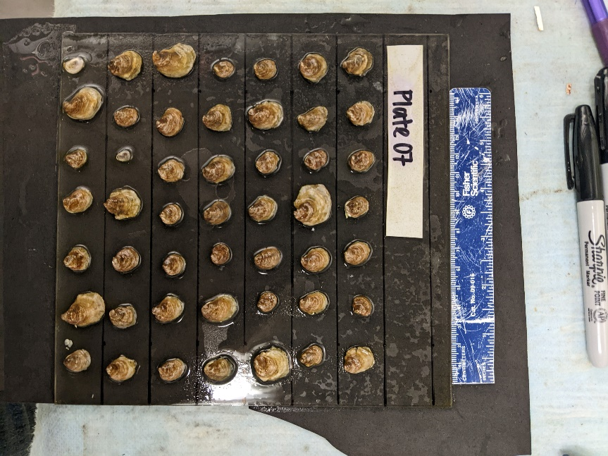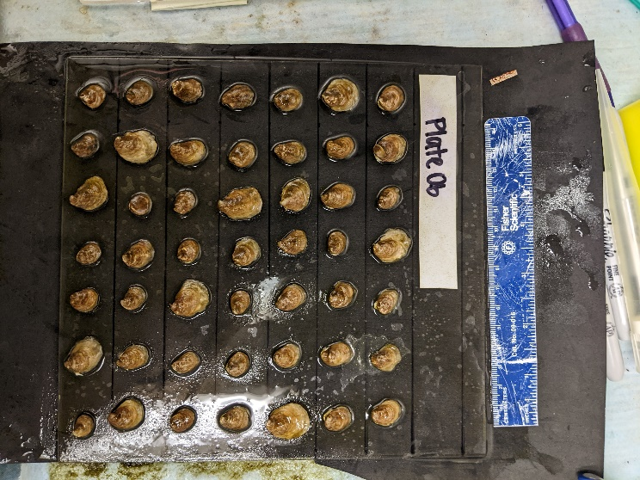

**0 dps**

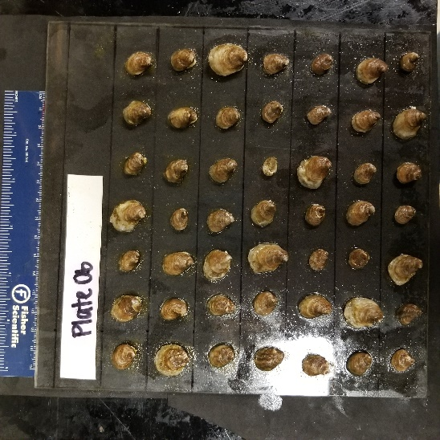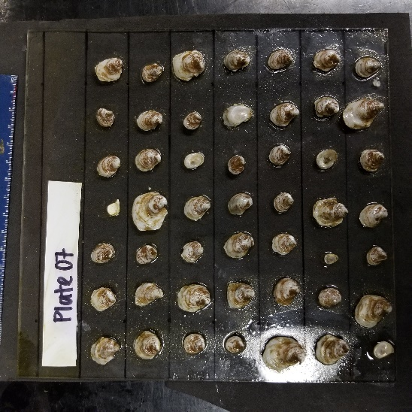

**18 dps**

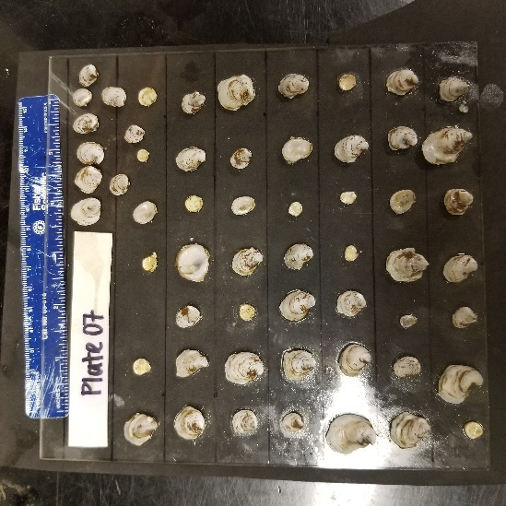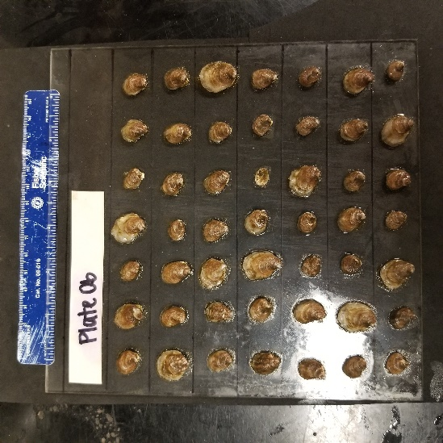

**36 dps**

***Need to mention the notoriously high variability in the highest TA treatments,***

Prior to arrival at BML, conditions in Tomales Bay were marine-dominated due to upwelling (cite), with many oysters still characterized as ‘dormant’ to professional farmers (personal comm.).

Oysters repurpose periostracum material as ‘cement’ to adhere to firm bottom when settling naturally.-->changes in perio under OA or changed food/more maintenance costs.

coastal ‘living wall’ protection from sea level rise along X coast (cite). Shells have been posed as a potential mitigation tool for coastal acidification (cite) and are the preferred substrate for growers (cite), thus extending their importance after death.

Oyster growth was positively influence by [TA], in ambient and low salinity conditions

1. When changes in [TA] occurred in ambient S conditions X happened
   1. Which was largely driven by high incremental growth in the first two weeks, with incremental growth declining between week 2-5 in the ambient and high TA conditions…(Fig 5)
2. Oyster growth is maintained when alkalinity is severely reduced below ambient conditions (60% reduction) in ambient salinity(Fig 2)
   1. Which was largely driven by an increase in incremental growth **after** 2 weeks of exposure to low TA conditions (Fig 5)
3. We also saw X effect of changes to [TA] coinciding with abrupt acclimation to low S conditions.
   1. Oysters exposed to freshwater inputs that have elevated [TA], have higher growth than those exposed to rainfall/low TA rivers (Fig3)
      1. Which was largely driven by increased incremental growth in the first two weeks, with incremental growth declining between week 2-5…(Fig 5)
4. We do not observe an additional influence of salinity on top of the positive relationship with [TA], which may occur because oysters were fed often and not energetically limited.
   1. Often times we see a non-additive effect when stressors are combined. We would look at the first two week growth rate in the single vs multi stressor experiment to test this relationship. In fact, we see X in reduced [TA] with no change in S versus X when S was reduced with [TA].

Effect of TA in low salinity… how was this similar or different to mussel work?

Comparison:

Stevens and Gobler: CV

* low pH lowered growth rate
* low pH took away the negative effect of low DO when coupled (ie only see pH effect)
* *low DO coupled with warmer temp decreased survival*
* *higher temp led to lower tissue wt*
* *low pH, low DO and high temp led to lower tissue weight*
* **across high and low salinity data combined, we did not see an effect of pH on net shell growth in oysters (even though some treatments had med omega calcite values less than one). This suggests that they were well fed and robust. However, we do see a change in net growth when TA is elevated in contribution to TA. In our case, low S interacting with TA produced a higher influence than either change alone.**

Parter: Saccostrea glomerata

* high co2 acclimation led to significant metabolic depression
* acute exposure to elevated temperature and reduced S (and low TA) with the higher CO2 treatment led to extracellular acidosis

Dickinson 2012: CV

* A graph of different types of dry mass

  Description automatically generated with medium confidenceexposure to elevated pCO2 and or low salinity (and low TA) led to significant increase in mortality, reduction of tissue energy stores and negative soft tissue growth
* responses to high CO2 and or low salinity (and low TA) indicate
* oysters respond to these stressors by becoming energy deficient, or, juvenile oysters maintain their cellular energy status at the expense of energy stores
* Under the conditions of our experiment, low salinity (and low TA) is a greater single stressor than high PCO2, whereas the combination of these two factors produces greater changes in the physiology and shell properties of these mollusks than each of the factors alone
* **We did not see an influence of Ta on mortality. Low salinity and low TA (di or low TA river) trended to have reduced survival, but it was not significant at the salinities we tested (was not the aim of our study). We saw no impact of S or TA on energy stores, tissue growth, even though others have seen impacts of pco2 on these components. We did not see oysters becoming energy deficient (maintained similar gut tissue, higher than controls), but we did see activity decline. They found that their low S (and low TA) treatment was stronger than any of the high pCO2 treatments. When coupled with high pco2, low S (and low TA) had a greater impact on physio and shell properties than each factor alone. (impetus for researching?)**

Waldbusser 2011: CV

* 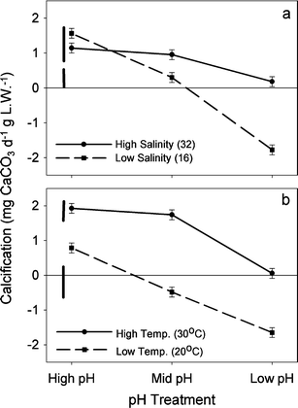comparing the effects of salinity (and TA) along pH treatments and temp treatments.
* High pH high the highest calcification (low S slightly higher and amb S), this also occurred at the highest TA
* The effect of high pH at high S is less than when coupled with decreasing S (and TA)
* *High Temp elevated calcification regardless of pH, and there was an independent decline in calcification from pH (similar to sal curve)*.
* The effect of pH at high S was minimal (black solid line)
* The effect of pH between S (and low TA) treatments were strong (dashed line)
* **We saw highest growth rates in the low salinity coupled with high alkalinity treatment, suggesting that oysters were able to optimize on their preferred condition quickly (effect was apparent by two weeks), with elevated TA becoming more important following the two week period, marginally.**
* **They didn’t see a strong effect of pH at ambient salinity; we didn’t see a strong effect of TA (and subsequently omega) at ambient salinity. The effect of diluting TA with freshwater (rain/hurricane) will also decrease the pH, and they showed it decreased calcification. We see that there is elevated growth when TA is elevated in low S, suggesting that the effect of low pH may not be as strong.**

Dickinson 2013: Hard shell clams

* Low S (and low TA) had profound effects on survival, energy metabolism and biomineralization of hard-shell clams
* Low S (and low TA) modulated clam response to high CO2
* Negative effects of low salinity (and low TA) were mostly due to the strongly elevated basal energy demand, indicating energy deficiency, that led to reduced growth, elevated mortality and impaired shell maintenance (evidenced by the extensive damage to the periostracum).
* Moderate hypercapnia (similar to 800 mu atm P-CO2) increased shell and tissue growth and reduced mortality high salinity exposures
* these effects were abolished under the low salinity (and low TA) conditions or at high P-CO2 (similar to 1500 mu atm)
* **similar: we saw trends of decreased survival in low S and low TA conditions only (but not profound effects like them). Difference: We did not see effects of low S and low TA on energy metabolism (ie gut wt). New material: we did see an elevated shell growth response to low S conditions coupled with high TA (they didn’t test). If low S doesn’t necessarily mean low TA, then estuaries may not experience the harmful consequences of high CO2. Moderate elevations in CO2 raised shell and tissue growth rates (maybe some sort of physio priming), like we see in low S and high TA?**

Gazeau 2013: Review

* in Benaish 2010 shell area was not impacted by high CO2 but shell mass lowered. This suggests that shells were thinner under high co2 conditions. As a note, their treatments spanned below omega calcite threshold of 1.
* (B) They suggest that shell area or length may not be sufficiently accurate as indicators of the effects of OA without measuring mass as well.
* **Our shell area was also not impacted by varying TA (and omega), which correlate with CO2. We did NOT see an effect of low TA on shell mass (ie shells were not thinner). Both our treatments and their span a range of omega values above and below 1. Suggest that just area or length may not be sufficient without understanding of mass.**

Hollarsmith 2019): Ostrea lurida and Crassostrea gigas

* the influence of carbonate system parameters, temperature, salinity, dissolved oxygen (DO) gradients is contingent upon the location in the estuary as well as seasonal timing (Hollarsmith 2019).
* During upwelling events (dry season), temperature, carbonate chemistry, and DO had the greatest impact on oyster performance. (Hollarsmith 2019)
* During runoff events (wet season), gradients in salinity, nutrient concentrations, and total alkalinity driven by river discharge were comparatively more important. (Hollarsmith 2019)
* the spatial importance *of carbonate chemistry and temperature* are seasonally variable and are two of several other factors that determine oyster performance. (Hollarsmith 2019)
* **Context for performance patterns overall: Performance was highest in upwelling season and declines following. We were between upwelling and river events and so there is some sort of transition in physio that is occurring such that, salinity, nutrients and TA are becoming more important. Future work should consider interval effects at different seasons, or consider outplants like these for CV in TX. Maybe because we were in a transition point, we saw depleted growth rates with time (coming down from upwelling?)**

A lot of studies have looked at the effects of altered conditions on net performances, however, this method doesn’t allow us to observe whether the effect is occurring in a similar nature throughout the course of the experiment. Plus, variability in the environment may be flashy, where conditions change abruptly, but persist over extended periods. It may be valuable to understand the degree to which responses to altered conditions change through time, as an organism may become more adjusted (especially in osmoconforming species like oysters).

Oysters are shell building species and respond to changes in carbonate system components. Others have looked to see how OA may impact oysters, but this occurred through varying pCO2. We were instead interested in seeing whether changes to TA conditions, either reducing or elevating, that occurs in estuaries without a corresponding salinity change, have a significant impact on shell growth.

Oysters preferentially live in low salinity estuaries that are impacted by freshwater. Especially within native ranges of this species, there is a high potential for rivers to elevate or maintain TA above ambient seawater. Most studies have looked at the effects of salinity on oysters by diluting with DI water, which simultaneously dilutes TA. These oysters may be responding to both salinity and carbonate system stress (cite), and therefore will likely have a different response to those experiencing low salinity and maintained TA.

We tested the influence of TA condition under lower, preferred salinity on net shell growth in oysters. We wanted to understand how the relationship between TA and shell growth may be mediated under low salinity by type of fresh water.

We were especially interested in comparing the responses of oyster growth to TA (in ambient and low salinity) through time, and so we compared growth patterns between two increments, the first spanning the first 2.5 weeks of exposure and the second, spanning 2.5 weeks after the first.

When oysters are really stressed they all do the same things

When they have ish stress, the variability in response increases

What is probably happening is that we are capturing changes in oyster growth phases where oysters are growing shell vs growing tissue, however, we do not have tissue samples from the midpoint to confirm.

Discussion : Low S (and low TA) had profound effects on survival, energy metabolism and biomineralization of hard-shell clams, Low S (and low TA) modulated clam response to high CO2 in Hard shell clams (Dickinson 2013)